Student Clustering and Major Prediction at the University of St. Thomas (Figures Only)
May 2025
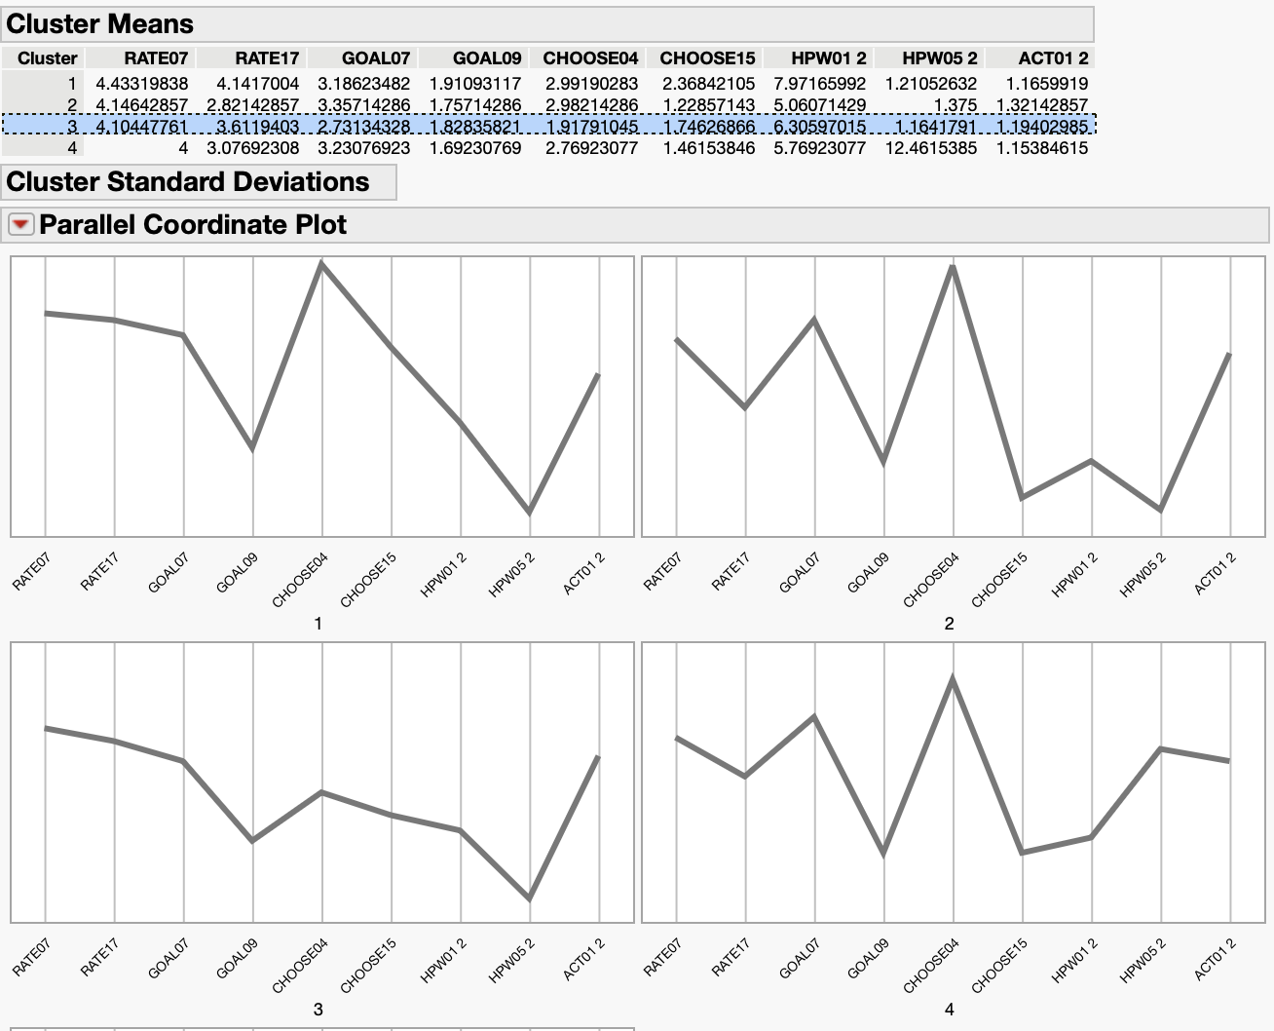
K-Means Clustering Parallel Coordinate Plots
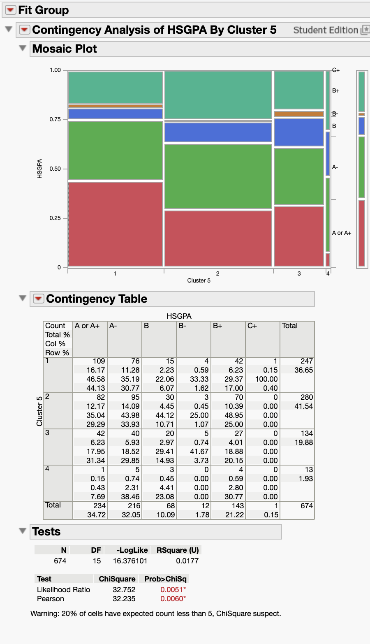
Contingency Table of HSGPA by Cluster
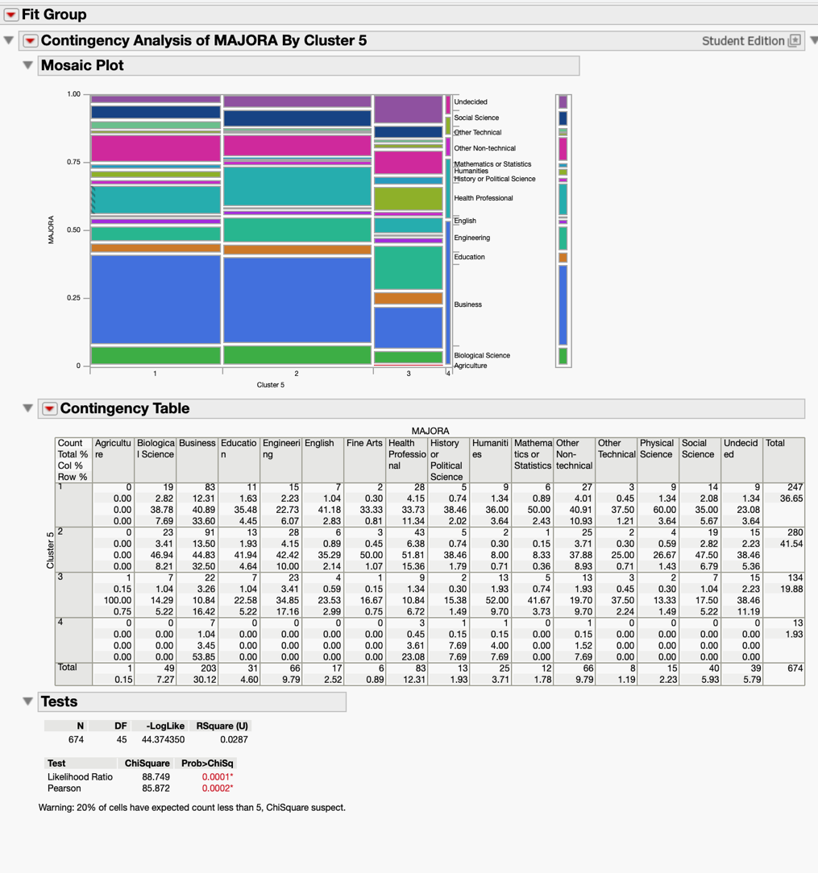
Contingency Table of MAJORA by Cluster
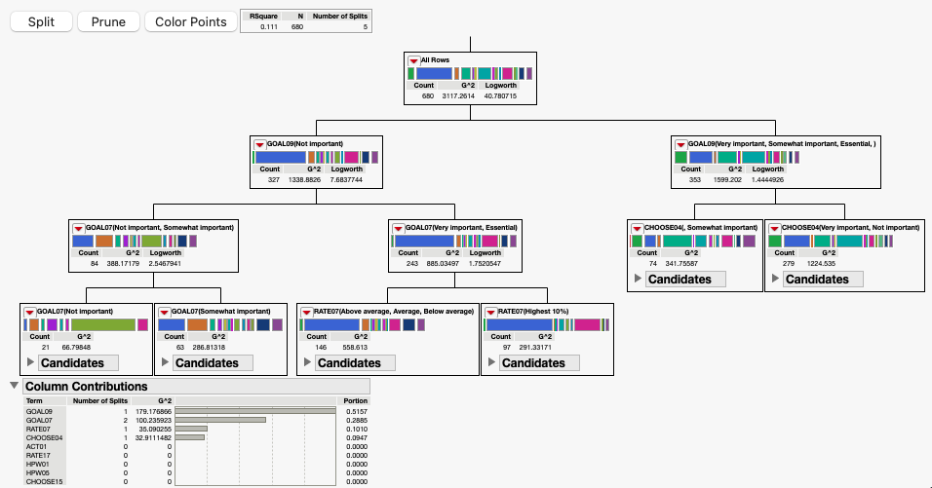
Decision Tree predicting MAJORA from the variables

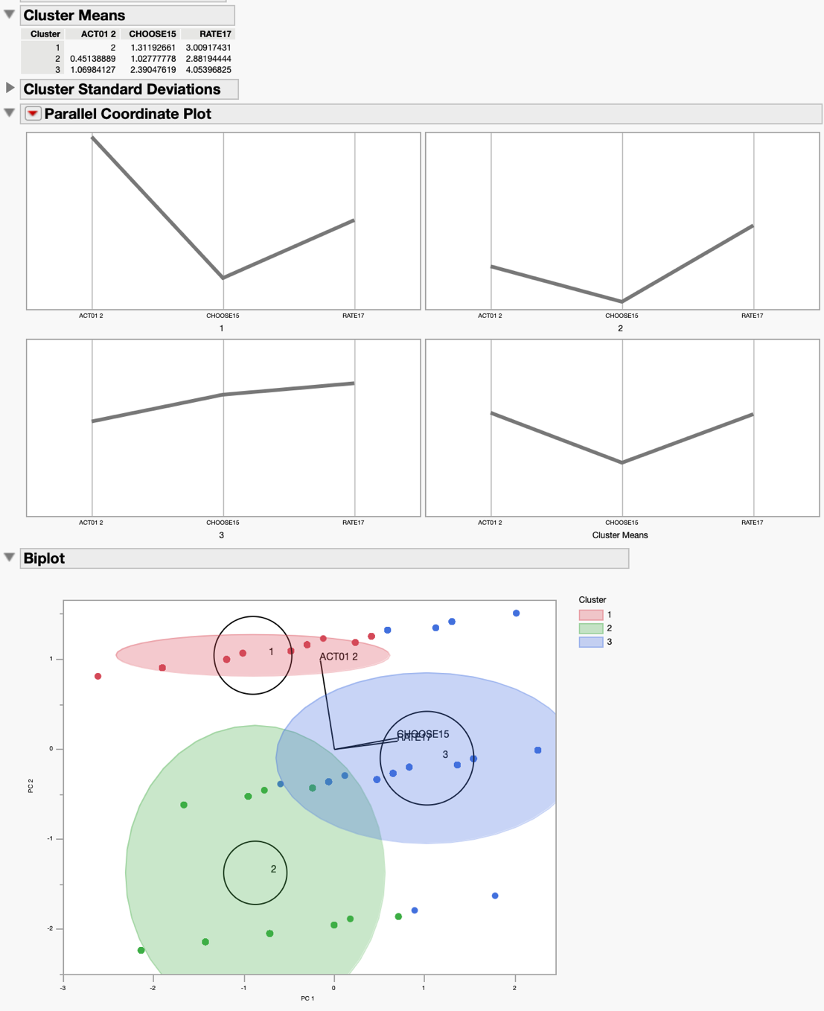
K-Means clustering of religious variables and Parallel Coordinate Plots

